# How to Export Contacts in Office 365 Exchange Online

## Introduction

Outlook Web App (OWA) allows us to import multiple contacts in a very simple way. However, it does not allow us to export contacts. In this application, we will demonstrate how to export contacts from Office 365 Exchange Online.

1. Get all the contacts from Office 365 Exchange Online.

2. Write the head title to the CSV file.

3. Write the contacts into the CSV file.

## Running the Sample

Press F5 to run the sample, we will get the following result.

First, we use our account to login the Exchange Online.



Then, we need to input the path of the folder that will be used to store the CSV file.



After that, we will create the file that contains the contacts.



Now you can find the file contacts.csv under the folder:

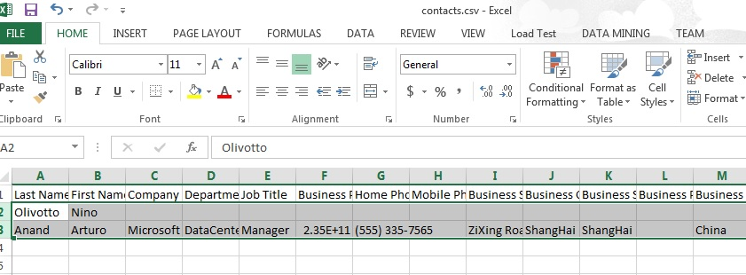

Then you can import the file into other accounts.

## Using the Code

1. Get the contact properties that you want to write into a CSV file.

The name of property is different from the column title of the file, so we store the property definitions and the column titles in the Dictionary. The key of the dictionary is the property definition, and the value is the column title of the CSV file.

|  |
| --- |
| -Code block start-  --C# code snippet start--  public static Dictionary<PropertyDefinitionBase, String> GetSchemaList()  {  Dictionary<PropertyDefinitionBase, String> schemaList =  new Dictionary<PropertyDefinitionBase, string>();  schemaList.Add(ContactSchema.Surname, "Last Name");  schemaList.Add(ContactSchema.GivenName, "First Name");  schemaList.Add(ContactSchema.CompanyName, "Company");  schemaList.Add(ContactSchema.Department, "Department");  schemaList.Add(ContactSchema.JobTitle, "Job Title");  schemaList.Add(ContactSchema.BusinessPhone, "Business Phone");  schemaList.Add(ContactSchema.HomePhone, "Home Phone");  schemaList.Add(ContactSchema.MobilePhone, "Mobile Phone");  schemaList.Add(ContactSchema.BusinessAddressStreet, "Business Street");  schemaList.Add(ContactSchema.BusinessAddressCity, "Business City");  schemaList.Add(ContactSchema.BusinessAddressState, "Business State");  schemaList.Add(ContactSchema.BusinessAddressPostalCode, "Business Postal Code");  schemaList.Add(ContactSchema.BusinessAddressCountryOrRegion, "Business Country/Region");  schemaList.Add(ContactSchema.HomeAddressStreet, "Home Street");  schemaList.Add(ContactSchema.HomeAddressCity, "Home City");  schemaList.Add(ContactSchema.HomeAddressState, "Home State");  schemaList.Add(ContactSchema.HomeAddressPostalCode, "Home Postal Code");  schemaList.Add(ContactSchema.HomeAddressCountryOrRegion, "Home Country/Region");  schemaList.Add(ContactSchema.EmailAddress1, "Email Address");  return schemaList;  }  --C# code snippet end--  --VB code snippet start--  Public Shared Function GetSchemaList() As Dictionary(Of PropertyDefinitionBase, String)  Dim schemaList As New Dictionary(Of PropertyDefinitionBase, String)()  schemaList.Add(ContactSchema.Surname, "Last Name")  schemaList.Add(ContactSchema.GivenName, "First Name")  schemaList.Add(ContactSchema.CompanyName, "Company")  schemaList.Add(ContactSchema.Department, "Department")  schemaList.Add(ContactSchema.JobTitle, "Job Title")  schemaList.Add(ContactSchema.BusinessPhone, "Business Phone")  schemaList.Add(ContactSchema.HomePhone, "Home Phone")  schemaList.Add(ContactSchema.MobilePhone, "Mobile Phone")  schemaList.Add(ContactSchema.BusinessAddressStreet, "Business Street")  schemaList.Add(ContactSchema.BusinessAddressCity, "Business City")  schemaList.Add(ContactSchema.BusinessAddressState, "Business State")  schemaList.Add(ContactSchema.BusinessAddressPostalCode, "Business Postal Code")  schemaList.Add(ContactSchema.BusinessAddressCountryOrRegion, "Business Country/Region")  schemaList.Add(ContactSchema.HomeAddressStreet, "Home Street")  schemaList.Add(ContactSchema.HomeAddressCity, "Home City")  schemaList.Add(ContactSchema.HomeAddressState, "Home State")  schemaList.Add(ContactSchema.HomeAddressPostalCode, "Home Postal Code")  schemaList.Add(ContactSchema.HomeAddressCountryOrRegion, "Home Country/Region")  schemaList.Add(ContactSchema.EmailAddress1, "Email Address")  Return schemaList  End Function  --VB code snippet end--  -Code block end- |

2. After getting all the contacts from Office 365 Exchange Online, we need to input the path of the folder that will be used to store the CSV file.

|  |
| --- |
| -Code block start-  --C# code snippet start--  private static String GetFolderPath()  {  do  {  Console.Write("Please input the floder path:");  String path = Console.ReadLine();  List<String> files = new List<String>();  if (Directory.Exists(path))  {  return path;  }  Console.WriteLine("The path is invaild.");  } while (true);  }  --C# code snippet end--  --VB code snippet start--  Private Shared Function GetFolderPath() As String  Do  Console.Write("Please input the floder path:")  Dim path As String = Console.ReadLine()  Dim files As New List(Of String)()  If Directory.Exists(path) Then  Return path  End If  Console.WriteLine("The path is invaild.")  Loop While True  Return Nothing  End Function  --VB code snippet end--  -Code block end- |

3. Then we write the contacts into the file.

|  |
| --- |
| -Code block start-  --C# code snippet start--  public static void WriteContacts(StreamWriter writer, PropertyDefinitionBase proerty, Contact contact)  {  if (proerty.Equals(ContactSchema.Surname))  {  if (!String.IsNullOrWhiteSpace(contact.Surname))  {  writer.Write("\"{0}\"", contact.Surname);  }  }  else if (proerty.Equals(ContactSchema.GivenName))  {  if (!String.IsNullOrWhiteSpace(contact.GivenName))  {  writer.Write("\"{0}\"", contact.GivenName);  }  }  else if (proerty.Equals(ContactSchema.CompanyName))  .............................  }  --C# code snippet end--  --VB code snippet start--  Public Shared Sub WriteContacts(ByVal writer As StreamWriter,  ByVal proerty As PropertyDefinitionBase,  ByVal contact As Contact)  If proerty.Equals(ContactSchema.Surname) Then  If Not String.IsNullOrWhiteSpace(contact.Surname) Then  writer.Write("""{0}""", contact.Surname)  End If  ElseIf proerty.Equals(ContactSchema.GivenName) Then  If Not String.IsNullOrWhiteSpace(contact.GivenName) Then  writer.Write("""{0}""", contact.GivenName)  End If  ElseIf proerty.Equals(ContactSchema.CompanyName) Then  .......................................................  End If  End Sub  --VB code snippet end--  -Code block end- |

## More Information

[EWS Managed API 2.0](http://msdn.microsoft.com/en-us/library/dd633709(v=exchg.80).aspx)

[Contact class](http://msdn.microsoft.com/en-us/library/exchange/microsoft.exchange.webservices.data.contact(v=exchg.80).aspx)